ASSIGNMENT – 1(SQLITE DATABASE)

1.Create a table for students with name, age, mobile no, registration no., year of batch as columns.

Query:

CREATE TABLE students2(ID INTEGER PRIMARY KEY AUTOINCREMENT,Name TEXT NOT NULL, Age INTEGER NOT NULL, Mobile_no TEXT NOT NULL, Regno TEXT NOT NULL,Batch INTEGER NOT NULL);

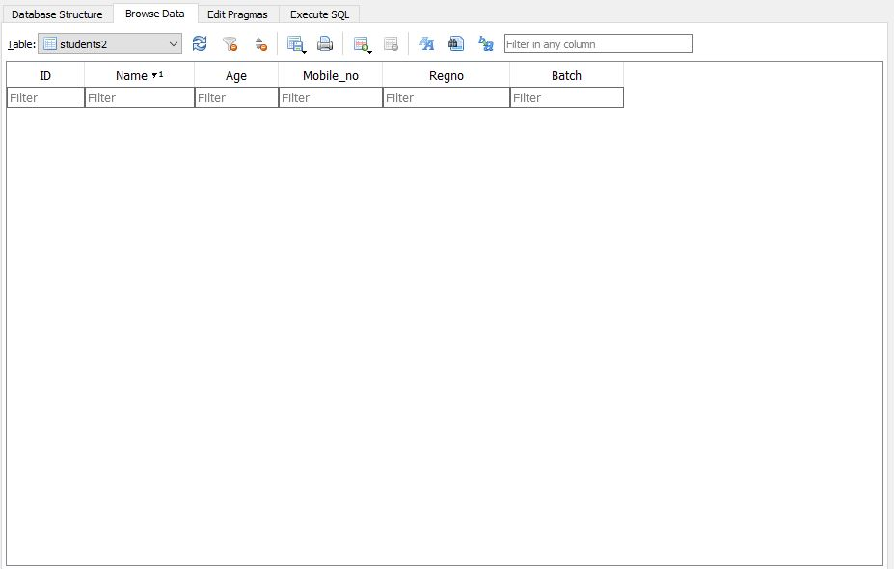

2.  Create a table for teachers with name, domain, department as column.

Query:

CREATE TABLE students(Name TEXT, Domain TEXT, Department TEXT);

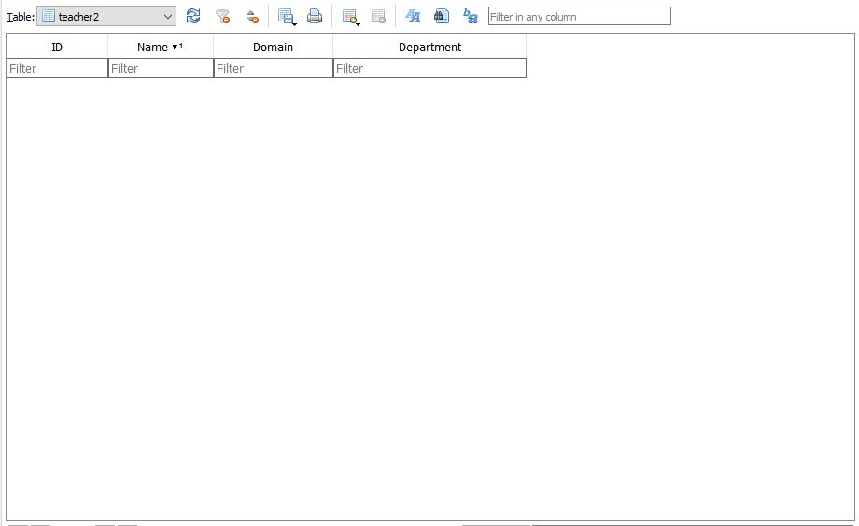

3.    Write a query to insert 10 students data and 10 teachers data in the respective table.

Students Table:

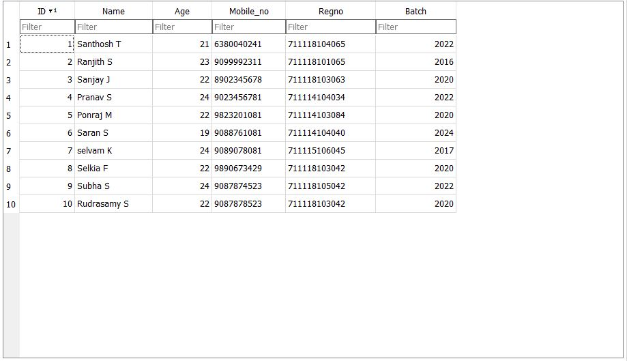

Teachers Table:

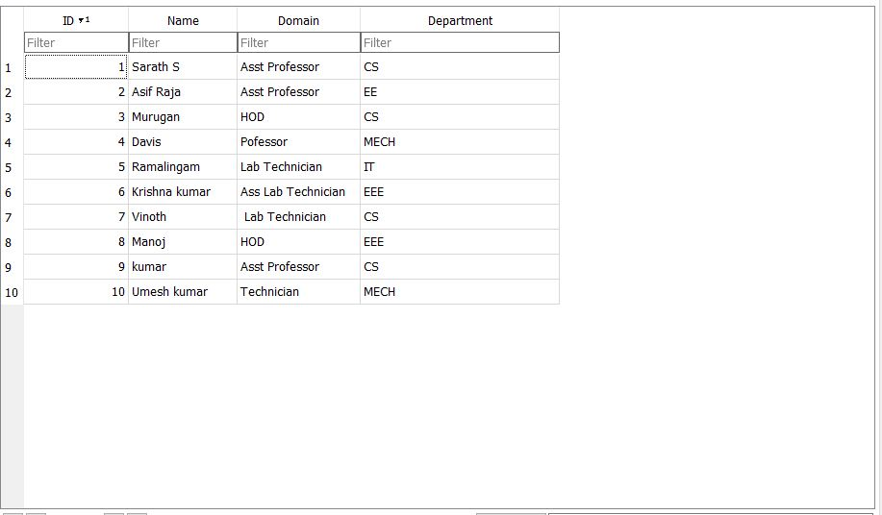

4.  Write a query to fetch all the students from 2020 batch.

Query:

SELECT * FROM students2 WHERE Batch=2020;

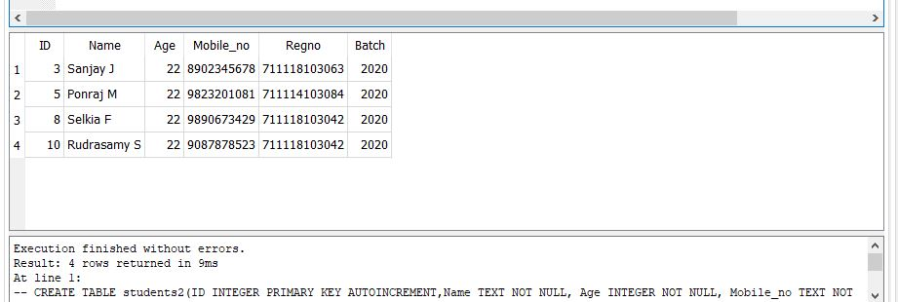

5. Write a query to fetch all teachers from CS department.

Query

SELECT * FROM teacher2 WHERE Department="CS";

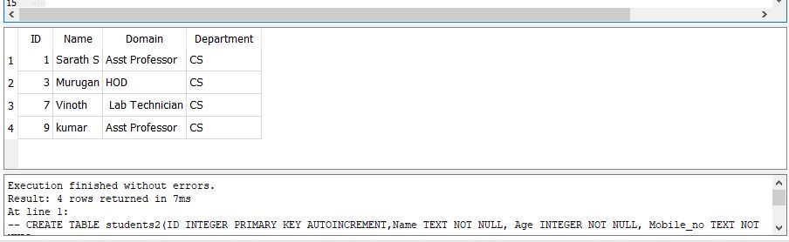

6. Write a query to edit at least 3 records of students.

Query:

Edited three records in th Table:

UPDATE students2 SET Name="Ram",Age=19,Mobile_no="8090515670",Regno="711119104056",Batch=2025 WHERE ID=3;

UPDATE students2 SET Name="Raju",Age=20,Mobile_no="8050534670",Regno="711117804050",Batch=2023 WHERE ID=5;

UPDATE students2 SET Name="Sudeep",Age=19,Mobile_no="8123329070",Regno="711117802050",Batch=2026 WHERE ID=8;

Before editing:



After Editing: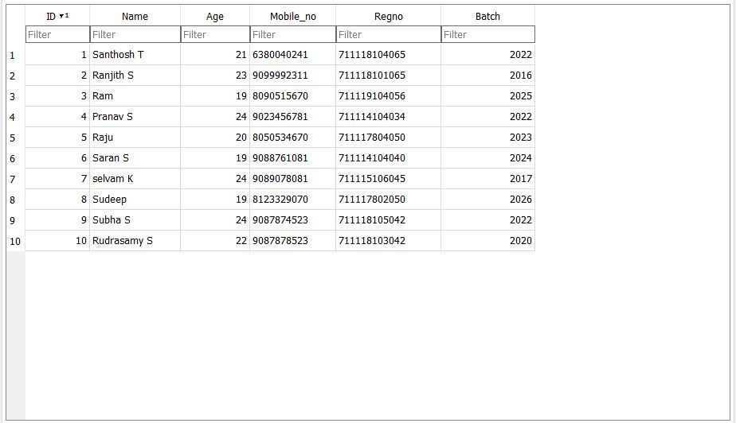

7. Write a query to delete 2 records from teachers table.

Query:

DELETE FROM teacher2 WHERE ID BETWEEN 9 AND 10;